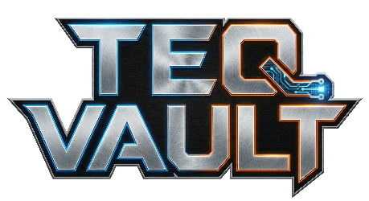
Teq Vault L.L.C.
Tel.: +17206657390
Email: support@teqvault.online
Web.: www.teqvault.online

INTELLECTUAL PROPERTY ASSIGNMENT AGREEMENT
THIS INTELLECTUAL PROPERTY ASSIGNMENT AGREEMENT (the "Agreement") is made effective as of March 22, 2026, by and between Jude Mensah Nana Baffoe ("Assignor") and Teq Vault LLC, a Louisiana Limited Liability Company ("Assignee").
1. THE ASSIGNMENT
For good and valuable consideration, the receipt and sufficiency of which are hereby acknowledged, Assignor hereby irrevocably sells, assigns, transfers, and conveys to Assignee all right, title, and interest in and to the following Intellectual Property (the "Assigned IP"):
- The Game: All source code, artwork, character designs, music, dialogue, and lore for the video game currently titled "Quetiemals: The Fight for Eyuforyia."
- The Book: All manuscripts, drafts, and world-building notes for the book adaptation of "Quetiemals."
- The Brands: All rights to the names "Teq Vault" and "Eyuforyia," including logos and associated trademarks.
- The Domains: Full ownership and control of teqvault.online and eyuforyia.com.
2. REPRESENTATIONS AND WARRANTIES
Assignor represents and warrants that:
- They are the sole creator and owner of the Assigned IP.
- The Assigned IP does not infringe upon the rights of any third party.
- They have the full right and authority to enter into this Agreement.
3. FURTHER ASSURANCES
Assignor agrees to execute any additional documents (such as copyright registrations or trademark filings) necessary to perfect Assignee's ownership of the Assigned IP.
4. GOVERNING LAW
This Agreement shall be governed by and construed in accordance with the laws of the State of Louisiana.

SIGNATURES
ASSIGNOR: ___________________________
Jude Mensah Nana Baffoe Date: March 22, 2026
ASSIGNEE (Teq Vault LLC): ___________________________
By: Jude Mensah Nana Baffoe Title: CEO
Date: March 22, 2026

